Motivation
One of the maxims about motivation is that you cannot motivate people. Does that sound discouraging? Well, the good news is—people are already motivated. You just need to discover and tap into the internal motivations that they already have. Create an environment where people are self motivated. So how do you tap into the internal desires of people that will motivate them to act?
The John Maxwell Company, in the article The Myth of Motivation suggests asking these questions in a one-on-one setting:
- What makes you cry? That is, what burdens your spirit or weighs heavily on your heart?
- What makes you sing? What activities bring you joy?
- What do you dream of doing or becoming?
Having pinpointed their primary motivators, you can then more accurately respond to their needs, position their strengths, and encourage their hopes.
Read through Nehemiah 1-3 and find some motivational practices that Nehemiah practiced:

Before getting into how to motivate people, let’s ask, “What are you wanting from people? Do you want commitment or compliance? What is the difference?”
Commitment | Compliance
Long term | Short term
Internally motivated | Externally necessitated
Extra mile | Just enough
Satisfies self (and God) | Satisfies others (the boss)

Here are some ideas on how to build commitment and motivated people:
- Embrace the idea that people do make and keep commitments.
- Be intentional and strategic in the commitments you ask for. You will get more if you ask less often. Don’t ask for less commitment, but don’t ask them to make too many commitments.
- Make sure you are committed and excited before you ask them to make a commitment.
- Show them the genuine value their work makes for the sake of the cause. People get excited when they can be involved in a purpose or cause that has a real impact. They get excited when they see that they had a part in something significant.
- Connect the task to their gift and passion.
- Create a sense of dissatisfaction. People won’t shift paradigms (and then values) until they get angry or uncomfortable. Dissatisfied people see the need for change. Connect that to how they can make a positive impact.
- Be specific (clear) and personal about the commitment you are asking for. Give them as much information as possible.
- Ask for feedback on their ideas. People support what they create. Nothing creates ownership better than allowing their input into goals.
- If possible, put people on teams, to give them support and community in their work.
- Try to make the job and the team fun.
- Forgive those who fail to keep their commitments. (Of course, this depends on how many times they have failed or how serious their failure was for the sake of the cause.)
- Celebrate (regularly) those who succeed in meeting their goals AND those who try something creative even if it fails. What you expect, inspect and then respect. Give praise both publicly and privately.
- Coach people for improvement. Keep communicating with them.
- Provide the tools and training needed for success.
- Tell stories of how people are fulfilling the mission (a type of praise).
- Help eliminate problems and diffuse conflict as quickly as possible.
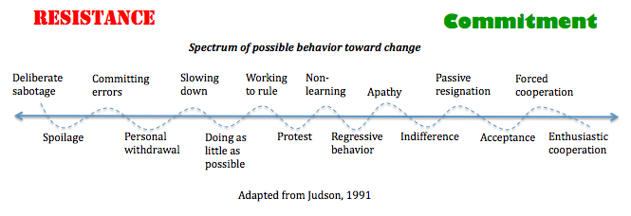
Application:
- Read 8 Things the Smartest Leaders Do to Motivate Their Employees by Marcel Schwantes, Empowerment Checklist by Jim Cathcart, Igniter Phrases and Killer Phrases, and The Myth of Motivation by The John Maxwell Company.
- Listen to Motivating Your Team (with show notes) by Craig Groeschel and How to Energize People by Jeff Brown
- Who do you need to motivate to action? What principles and steps will you use to motivate them? Develop a plan.

