New Year, New You
Select Scriptures
December 30. 2018
Well, this is the time of year when each year we start thinking about goals for the next year. We make resolutions, but usually fail to keep them. We start diets. We determine that we’re going to make progress in our relationships, in our finances, even in our spiritual lives.
Wouldn’t it be great to be able, at the end of 2019, to see observable progress in your spiritual life? Wouldn’t you like to see that?
We only have one life to live. It is a gift from God and we are to steward our lives for His glory. To live selfishly and leisurely is not the best use of the life God has given to us. I want to encourage you to make your life count.
If you’re over 50, like me, it is good to get regular medical check-ups. Doing that allows us to discover what needs to change in our diet, exercise or lifestyle. Every once in awhile God will give us a window into our spiritual lives, or our relational lives, as well. We may have a “wake up call” and come to our senses and see the need to change.
Much of the time, when we review the previous year, we would find it difficult to recognize any observable progress that we have made.
I know I would like to see progress in my life, even as old as I am. I don’t just want to sit on my laurels and let life pass by, congratulating myself for how far I’ve come but being “too easily pleased.”
Paul felt this way. In Philippians 3 Paul uses athletic language to describe his desire to keep making progress. He says…
13 But one thing I do: forgetting what lies behind and straining forward to what lies ahead, 14 I press on toward the goal for the prize of the upward call of God in Christ Jesus.
Paul wasn’t content with where he was in his walk with Christ. He was focused on “one thing” and wouldn’t let anything distract him. He knew he had to put the past behind to move forward.
Now, notice that the past for Paul wasn’t past failures. He’s talking about those achievements and his pedigree that he had mentioned back in vv. 5-6
5 circumcised on the eighth day, of the people of Israel, of the tribe of Benjamin, a Hebrew of Hebrews; as to the law, a Pharisee; 6 as to zeal, a persecutor of the church; as to righteousness under the law, blameless.
Those were good things. Those were trophies from his past life. But he trashed them for the sake of gaining Christ. Those things had been gain, but he now counted them loss for the sake of Christ.
So he “forgets what lies behind” and now keeps “straining forward to what lies ahead.” He knows that God has called him forward and upward and like a runner makes that last desperate effort to throw himself across the finish line, Paul is giving his greatest effort every day to reach the goal that God has called him to.
God has called you and me to become like Jesus Christ. To first embrace Him as Savior, to trust in what He has done on the cross for us, but then to become like Him.
Both involve faith. We trust Christ for salvation and then we trust Him to live His life through us.
So I want us to “press forward” this year. I want us all to experience observable progress in our lives this year. I want to encourage you to get goals and stretch forward to those goals.
I know it isn’t easy. I’ve set goals and resolutions many times and did well for 2-3 days, but didn’t keep it up. But I want to encourage you to try again. If, for example, you start a bible reading plan, and find yourself behind after one or two weeks, I want to encourage you to try again. Get back into the habit and even if you don’t catch up, you will benefit.
So before we talk about specific ways to develop a “new you” in this new year, let’s see what the Bible says about setting goals.
Proverbs 19:21 says…
“Many are the plans in the mind of a man, but it is the purpose of the LORD that will stand (ESV).”
One version puts it this way: “People may plan all kinds of things, but the LORD’s will is going to be done.”
What does that mean for you and me today? It means that whatever we might plan, we need to make sure it aligns with God’s plans for us.
Solomon is not discouraging us from making plans, setting goals, making resolutions. In fact, elsewhere in the Bible God calls us to plan for our future, “The plans of the diligent lead surely to abundance” (Prov. 21:5).
Or another version translates this verse as follows, “Plan carefully and you will have plenty.”
According to this verse we are to plan carefully, and yet as we make plans, let us realize that our plans are subordinate to God’s sovereign will. God’s eternal plan is supreme over all our plans. Therefore, not all that we plan will come to pass.
The word plans in Proverbs 19:21 comes from the Hebrew verb khawshab which means to think of something that you want to do: “Many are the plans in the mind of a man.” Plans are activities you think about doing in the future.
The word “mind” here is the word for “heart,” because the heart, in the Bible, is our CPU, central processing unit. It is in the heart that we think, experience feelings and make decisions on what we will do.
We see this problem of our hearts planning something that is not God’s purpose in the parable of the Rich Fool. He made plans for his whole life. He was good at the process of planning, but didn’t keep God’s will in mind.
“And he [the rich fool] said, ‘I will do this: I will tear down my barns and build larger ones, and there I will store all my grain and my goods. And I will say to my soul, ‘Soul, you have ample goods laid up for many years; relax, eat, drink, be merry”’ (Luke 12:18-19).
The rich fool made selfish and greedy plans. Oh, but listen to what God says in Proverbs 19:21, “Many are the plans in the mind of a man, but it is the purpose of the LORD that will stand.” The word purpose here comes from the Hebrew verb that means to determine. God’s plan was settled from before the foundations of the world.
So make sure your plans align with God’s plans for you.
Your life can change, you can make progress this year, when you develop a God-honoring, biblical plan and remain focused and intentional about following it.
When the gauges on your car show that something is wrong, don’t take a hammer and crush it. Pay attention to what it is saying and do something about it.
- Discernment is checking and evaluating the gauges in our lives
- Discipline helps us take action when one of these gauges tells us something needs changing
- Determine helps us stick to it when the going gets rough
So we need to develop discernment, discipline and determination.
Hebrews 12:1 tells us that if we want to “win the race” we must…
let us also lay aside every weight, and sin which clings so closely, and let us run with endurance the race that is set before us,
To make progress, our gauges may tell us that there are some things that we must jettison from our lives if we are to run well. “Weights” are not necessarily sinful things, but they do slow us down from making progress. Also, there may be “sins” that cling to us and we have to remove those barnacles to keep us from being slowed down.
This morning I want to challenge you to make goals and plans for six areas (six gauges) of your life and we will begin with the most important one this morning.
- Develop spiritual goals for 2019

Doesn’t it seem obvious that God would want us make progress spiritually. His goal in our lives, what he predestined us for, is to “be conformed to the image of his Son” (Romans 8:29). He wants us to put on the character of Christ, the fruit of the Spirit in our lives more and more each day.
But spiritual growth doesn’t happen automatically. It doesn’t happen without effort on our part. God’s power is there to enable us, but we must be active. We cannot expect to become more like Christ by just watching TV and playing games on our phones.
We are to “work out [our] own salvation with fear and trembling, for it is God who works in you, both to will and to work for his good pleasure” (Philippians 2:12b-13).
It is obvious from this verse that working out our salvation and intentionally pursuit Christlikeness is God’s good pleasure for us. So as He gives us the “desire” (the will) and the “energy” (work) we “work out our salvation.”
In order to grow spiritually, we have to (1) tell the truth about ourselves and (2) listen to the truth about ourselves. We need to admit that we sin and fail God, as the Bible tells us. But we also need to listen to the truth that we are deeply loved and graced and that God is willing to forgive us no matter what we have done.
That is the starting point of the Christian life—admitting our sin and accepting our Savior, acknowledging that we have sinned and accepting the grace of Jesus Christ expressed through His willingness to take our sin debt upon Himself and die for us on the cross.
So how do we become more like Christ this year? Simply put, by doing the things that Christ did. Yes, He was God, and we cannot imitate that. But He lived His time on earth as a man dependent upon the Holy Spirit. As such, we can imitate Him.
Here is the most important thing that Jesus did that we need to do in order to make spiritual progress in 2019. And that is regular Bible intake.
One of Jonathan Edward’s resolutions was…
28. Resolved, to study the Scriptures so steadily, constantly and frequently, as that I may find, and plainly perceive myself to grow in the knowledge of the same.
My suggestion is to read the Bible daily and study the Bible monthly. Now, if you are a Sunday School teacher, you will need to study the Bible weekly, or several days a week.
Just as your body needs more than one meal a week, so your spirit needs more than one interaction with Scripture a week. Don’t depend on Sunday sermons alone to do the job.
You will make progress if you read and interact with Scripture every day.
There is much research that shows the correlation between spiritual maturity and reading the Bible. In Brad Waggoner’s book The Shape of Faith to Come, which is based on a LifeWay Research study, and in George Guthrie’s Read the Bible for Life material, we see that reading the Bible is the best predictor of spiritual maturity. In other words, if you are in the Bible, you are growing spiritually.
God’s Word is “alive and powerful” and will not return to God without doing its work. It has a performative action in our lives even when we don’t realize it.
This is why Paul told the Thessalonians in 1 Thessalonians 2:13
And we also thank God constantly for this, that when you received the word of God, which you heard from us, you accepted it not as the word of men but as what it really is, the word of God, which is at work in you believers.
Whatever Scripture you put into your mind and heart, is currently at work in you.
So get more and more Scripture in your mind and heart.
So choose a Bible reading plan for this year. There are 90 day plans, one year plans, two year plans and three year plans. I will have access to all those plans up on my blog tomorrow, as well as other goals that we will talk about this morning.
I am going to follow one of those plans and blog regularly on some insights I’ve learned.
Listen to sermons weekly, read the Bible daily, study it monthly, memorize it and meditate upon it. You will find yourself making more progress against temptations, guarding your thought life and regulating your behavior the more you do all five of these Bible intakes.
Secondly, pray each day. Jesus often got alone to pray. He knew just how vital it was not only for His mission, but also for His own heart.
I would encourage you to get the PrayerMate app for your phone. Or, you can list names in the Notes app on your phone. You can set alarms to remind you to pray.
Praying is simply conversing with God. It is acknowledging that we need Him. We are dependent upon Him.
There are other things that Jesus did to grow in favor with God and man, such as worship, community, fasting. All of those are spiritual disciplines that are wise to do regularly or from time to time.
The way we become more like Christ is to do the things that He did—to pursue the spiritual disciplines that Jesus exercised.
- Develop physical goals for 2019
We exist as body, soul and spirit. Sometimes we act as if the body is the least important part of our nature, but in fact it is vitally important. And every part needs to be dedicated to God.
Ronnie Floyd, pastor of Cross Church in Springdale, says that he periodically prays (and this would be a good every day prayer!): “Lord, I surrender all of me to all of You so that all of You will live in and through all of me.”
We must remember that our entire life is connected, and not compartmentalized. Our Christian faith should affect all of our lives, Sunday through Saturday.
Unfortunately, Immanuel Kant divided the sacred and secular and since then more and more of life has been relegated to the secular and very little is left for the sacred.
That is not the biblical ideal. Biblically all that we do in every sphere of life is sacred, no matter how mundane or physical.
I love what Abraham Kuyper, a Dutch theologian once said…
“There is not a square inch in the whole domain of our human existence over which Christ, who is Sovereign over all, does not cry, Mine!”
And that includes our bodies. It is in our bodies that our spirit dwells, and thus Paul challenged the Corinthians with these words…
19 Or do you not know that your body is a temple of the Holy Spirit within you, whom you have from God? You are not your own, 20 for you were bought with a price. So glorify God in your body. (1 Corinthians 6:19-20)
We are to glorify God “in our bodies.” Thus, the very first step in our spiritual worship is to offer our bodies to God. Listen to Paul’s words in Romans 12:1…
1 I appeal to you therefore, brothers, by the mercies of God, to present your bodies as a living sacrifice, holy and acceptable to God, which is your spiritual worship.
Even in heaven we will have new bodies, so God designed that we would be embodied spirits, now just spirits. So our spirituality is expressed through our bodies.
So what should we do with our bodies this year? Live healthily.
Set some exercise goals. Again, I will have some possible plans on my blog tomorrow.
I learned from my neurologist that walking regularly helps ward off dementia and Alzheimers.
So plan to walk, or jog, or run regularly. Also, there will be some other stretching exercises you can do.
Now, while exercising, you can listen to podcasts. Those podcasts can help you will other goals. You can listen to preaching and teaching, practical information relating to specific goal areas, books, etc.
Also, eat nutritionally. Believe me, I’m not very good at this and just about anything I do would be a visible improvement over last year!
Again, there will be some information on my blog Monday that can help you eat nutritionally.
Thirdly, get good sleep. Many studies have shown that even as adults we need 7-9 hours of sleep each night. That may seem like laziness to you, or a luxury you cannot afford, but in reality you can get more done in fewer waking hours when you get good rest.
Sleep is a good gift that God gives to us and is an act of trusting God to work even while we sleep.
Now, Paul tells us this about physical discipline:
7 Have nothing to do with irreverent, silly myths. Rather train yourself for godliness; 8 for while bodily training is of some value, godliness is of value in every way, as it holds promise for the present life and also for the life to come.
So Paul is not saying that bodily training is of no value, but that it is of some value. Training in godliness (spiritual goals) is more important, but I think I can say this: that when we discipline ourselves bodily, we find it easier to discipline ourselves spiritually.
Or, to put it another way, lack of discipline physically usually leads to lack of discipline spiritually. So even though spiritual goals are more important, they often depend upon physical goals.
Now, there are some obvious things we need to eliminate from our bodies—such as gluttony, drunkenness, sexual immorality and laziness.
So each day, submit yourself to God, give your body to God, take care of it and glorify God with it.
Our desire should be, like David, to “serve the purpose of God in our own generation” (Acts 13:36). We won’t be able to do that unless we take care of ourselves.
Thirdly, I want to encourage you to…
- Set relational goals for 2019
Just as God exists as a community of three, so we are made to live in community. God designed marriage and the family, but also the church, to be a place where deep, meaningful friendships could be developed.
Let me ask you about your current relationships:
- Are they refreshing or irritating?
- Replenishing or draining?
- Peaceful or stressful?
- Calming or dramatic?
Any relationship can be improved. Jesus wants us to be refreshing, replenishing, peaceful and calm. I like what Paul said about Philemon
7 For I have derived much joy and comfort from your love, my brother, because the hearts of the saints have been refreshed through you.
Do you have one relationship that could be better this coming year? What do you need to do?
Do you need to pursue a friendship? I know that many of us men have few friends, maybe none. Set a goal to pursue a friendship this year.
Do you need to reconcile a relationship? Is there someone that you have refused to forgive, for years? You can make visible progress in that relationship and in your own spiritual life by forgiving.
I want you to notice what the writer of Hebrews says in Hebrews 12:15
15 See to it that no one fails to obtain the grace of God; that no "root of bitterness" springs up and causes trouble, and by it many become defiled;
What is most alarming about that verse is the first part. It is saying that if bitterness “springs up” in our hearts, not only does it cause trouble and defile many, but it causes us to “fail to obtain the grace of God.”
I think he is saying that Jesus said, when he said…
14 For if you forgive others their trespasses, your heavenly Father will also forgive you, 15 but if you do not forgive others their trespasses, neither will your Father forgive your trespasses.
I don’t think these verses are saying that our forgiveness from God depends on our ability to forgive others, otherwise we would lose our salvation. I think what Jesus is saying is that when we fail to forgive others, we will have a hard time believing and experiencing our own forgiveness from God. We will naturally doubt it. We will miss out on the current benefits of being forgiven, when we fail to forgive.
Let me just suggest a couple of other things. If you want to make observable progress in your marriage, you might try Brad Hambrick’s 240 Marital Conversations, learn one another’s love language, and identify at least two things each day that you can do to make deposits in your mate’s love bank.
Try to improve your marriage this coming year. Improve your relationship with your children, with your co-workers, with your friends.
The biggest problem in relationships is usually selfishness—we want to do what we want, when we want it and we want others to bow to us and serve us. On the surface, that sounds pretty bad, doesn’t it?
To be unselfish you have to decide to die to yourself—to give up your plans, your control, your comfort. You have to initiate healthy relational habits.
If you have a hard time loving someone, then don’t just screw up your determination and force yourself to love them. Concentrate on living in the love of Jesus Christ. Ask God to reveal to your heart how high and wide and deep and long is the love of Christ for you.
“We love because he first loved us” (1 John 4:19) and when we know and rely upon His love for us, we have a greater sense of security to be able to extend ourselves to love others.
Remember that biblical love is doing what is best for the other person, even at great personal cost and even when they don’t deserve it.
That is how Jesus loved us.
Set some relational goals. Try to meet someone you admire. Contact a long lost friend. Find a mentor. Visit and serve someone in the nursing home.
UCLA basketball coach John Wooden once said: “Five years from now, you’re the same person except for the people you’ve met and the books you’ve read.”
So set some relational goals.
Fourthly,
- Set some financial goals for 2019.
Not only our nation, but most individuals are deeply in debt. Even Christians.
Since we know that all we have belongs to the Lord and we are stewards of it, it is only right that we keep ourselves financially fit as well. If we are unhealthy in our finances, it will affect other areas of our lives—adding stress to our relationships and our bodies.
Here are some practical things you can do this year:
- Get on a budget. Develop a budget on paper, adjust as needed, to try to keep to it.
- Get out of debt. The borrower is slave to the lender all the time. Pay them off one by one and try to stay out of debt. Cut up your credit cards if you cannot pay them off monthly.
- Save. Each paycheck put some aside for savings.
- Give. Make a habit of giving regularly to God’s work in your church and other ministries.
Remember that Jesus tells us how we look at money is a very significant indicator of our heart’s desires: “For where your treasure is, there your heart will be also” (Matthew 6:21).
Two goals that will make the greatest difference in your life are to (1) get out of and avoid debt and (2) give at least 10% to God. That, of course, is the floor of giving, not the ceiling. The more you give the greater you will grow.
If you haven’t done it yet, take the Financial Peace University course from Dave Ramsey.
Your most important portfolio is not on paper, but in the lives of your children and grandchildren. You can impact their lives spiritually and relationally, but also financially.
Ronnie Floyd indicates six ways we can leave an indelible mark on the next generation:
- Live a life of unique godliness
- Encourage love for God and living for God in your children and grandchildren
- Pray for them daily
- Invest in the next generation, even those who aren’t your children
- Leave money after your death
5. Set emotional goals for 2019
Solomon prompts us to “Keep your heart with all vigilance, for from it flow the springs of life” (Proverbs 4:23). Remember that the heart is the CPU, the command center, the mission control of all our life. Everything starts there.
It is the place where we process information, attach value to things and make decisions which result in certain behaviors.
Jesus told his disciples that
19 For out of the heart come evil thoughts, murder, adultery, sexual immorality, theft, false witness, slander.
Of course, good things can come out of a redeemed heart that is being sanctified, but this is why we must “watch over our hearts with all diligence.” We dare not ignore our hearts.
We are also to watch over our steps.
17 The highway of the upright turns aside from evil; whoever guards his way preserves his life.
In the past couple of decades EQ has surpassed IQ as something that hiring departments are looking for.
Emotional intelligence: “the ability to monitor one's own and others' feelings and emotions, to discriminate among them and to use this information to guide one's thinking and action.”
So this means watching our gauges, identifying our feelings, and then guiding them.
It is not always easy to know what is going on in our hearts. Jeremiah tells us that…
“The heart is deceitful above all things, and desperately sick; who can understand it?” (Jeremiah 17:9).
The next verse tells us that God can test the heart and know it accurately. Again, that is why we need God’s Word to help us define our hearts, as well as other people.
The Johari Window helps us see that we are most healthy and our relationships are most healthy when we tell the truth about ourselves and listen to the truth about ourselves.
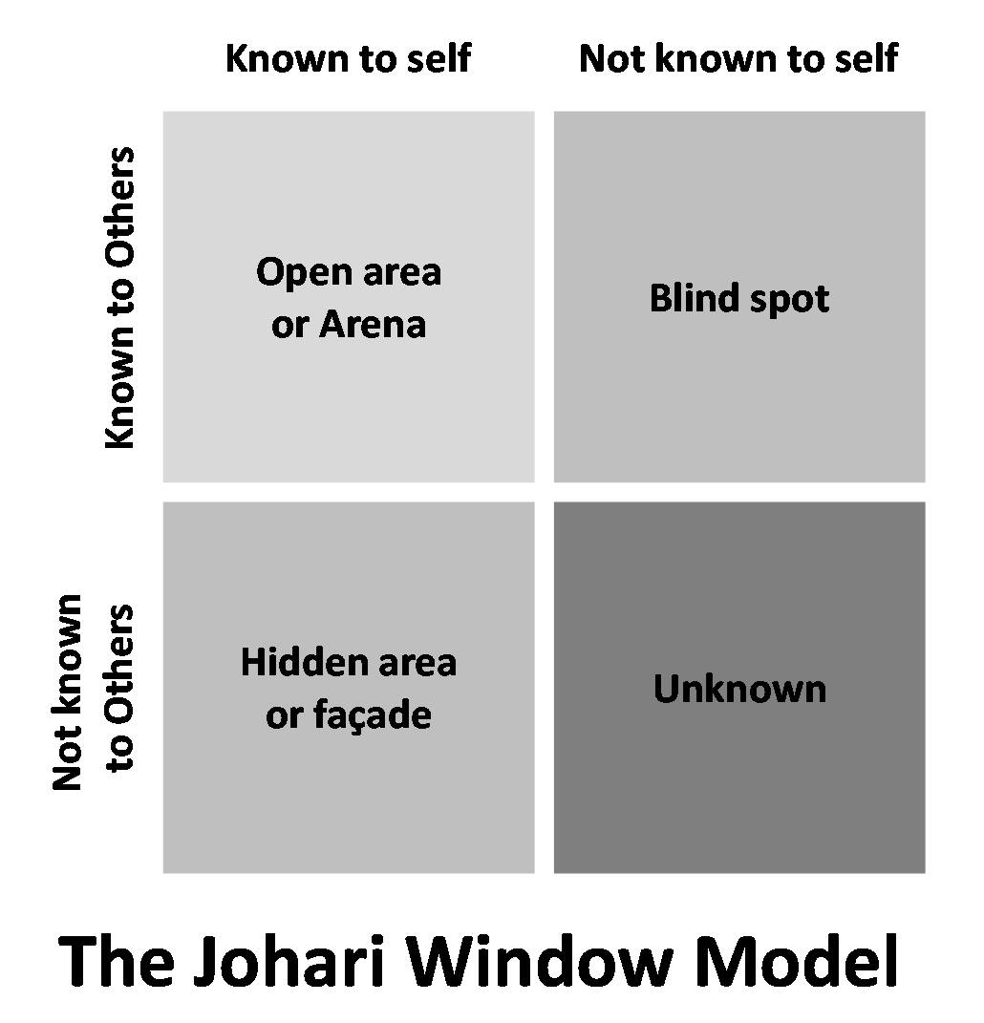
Our goal should be to increase the open area. We do that by self-disclosure so that the hidden area is minimized and soliciting feedback so that the blind spots are minimized. What is unknown to ourselves and others can only be revealed through revelation from God.
Can you identify how you are feeling? Most guys have difficulty with that. We retreat into our “nothing” box when talk about feelings surfaces.
But identifying and understanding our feelings is a key way to experience deeper spiritual and relational health. David blabbed his feelings to God in the Psalms. Our wives would love it if we talked with them about our feelings.
So, on the blog I’m including Feelings Inventory to help you identify your feelings and an assessment from the Emotionally Healthy Church book by Warren Bird and Pete Scazzero. These can help you work through some things and identify your feelings.
One goal you can set for your emotions is gratitude. Gratitude will produce joy in your heart. I would suggest setting a goal for yourself to write out 3-5 things you are grateful for each morning.
Rejoicing in worship is good for the heart. Take time to express your gladness and delight in the Lord and His goodness to you.
Serving others can also help you emotionally. When you feel down and discouraged, make a plan to go help somebody else. It will lift you up.
Write a thank you note to someone. Comment on how their attitude, behavior, changes have been a blessing to you.
Finally
6. Set mental goals for 2019
It is important to be a life-long learner. Never stop learning. If you are a leader, you are a learner. When you stop being a learner, you stop being a leader.
Remember that UCLA basketball coach John Wooden once said: “Five years from now, you’re the same person except for the people you’ve met and the books you’ve read.”
Get away from the TV and read a book this year. You might set a reading goal of 30 pages a day. That would even get you through War and Peace this year!
Seriously, identify some good books and read them this year. I have my reading list.
Of course, you can also listen to audible books. Go to iTunes on your computer and search for a book. I’ve got books by Jules Verne and Alexander Dumas that I could never find in print.
Another learning goal could be to take an online course. You can take courses in almost anything, even seminary courses, on YouTube. Hillsdale College offers free courses.
Another way to learn is to keep a journal. You can record thoughts from reading, from experiences, from conversations. As you record them and think about them, you are learning.
Another way to continue to learn is to find a mentor.
So, I want to see observable progress in my life this year—spiritually, physically, relationally, financially, emotionally and mentally.
In fact, 1 Timothy 4:15 says that my progress should also be evident to you.
15 Practice these things, immerse yourself in them, so that all my see your progress.
Listen to the larger context. It’s really good!
12 Let no one despise you for your youth, but set the believers an example in speech, in conduct, in love, in faith, in purity. 13 Until I come, devote yourself to the public reading of Scripture, to exhortation, to teaching. 14 Do not neglect the gift you have, which was given you by prophecy when the council of elders laid their hands on you. 15 Practice these things, immerse yourself in them, so that all may see your progress. 16 Keep a close watch on yourself and on the teaching. Persist in this, for by so doing you will save both yourself and your hearers.
That’s a strong encouragement to me that I need to keep making progress.
But I hope that you also want to see progress in these areas in your life.
My recommendation: Keep it simple. Don’t set 10-15 goals, but maybe one in each area. You can add more next month or next year. And, if you get behind, don’t quit; start again.
And my hope is that each of us sees progress in our lives in 2019.

